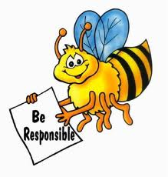

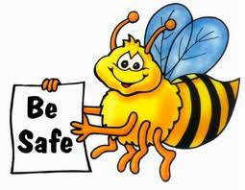
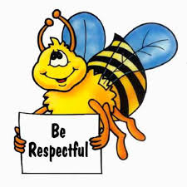
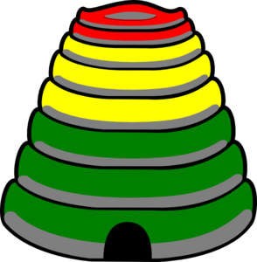

In the Learning Environment
Name: _____________________
Date: _______________
Be Safe

__________________________________________________________________________________________________
_____________________________________________________________________________________________________________________________________________________________________________________________________________________________________________________________________________________________________________________________________________________________________________________________________________________________________________________________________________________________________________________________________________________________________________________________________________________________________________________________________________________________________________________________________________________________________________________________________________________________________________________________________________________________________________________________________________________________________________________________________________________________________________________________________________________________________________________________________________________________________________________________________________________________________________________________________________________________________________________________________________________________
Be Respectful

_____________________________________________________________________________________________________________________________________________________________________________________________________________________________________________________________________________________________________________________________________________________________________________________________________________________________________________________________________________________________________________________________________________________________________________________________________________________________________________________________________________________________________________________________________________________________________________________________________________________________________________________________________________________________________________________________________________________________________________________________________________________________________________________________________________________________________________________________________________________________________________________________________________________________________________________________________________________________________________________________________________________________
Be Responsible

_____________________________________________________________________________________________________________________________________________________________________________________________________________________________________________________________________________________________________________________________________________________________________________________________________________________________________________________________________________________________________________________________________________________________________________________________________________________________________________________________________________________________________________________________________________________________________________________________________________________________________________________________________________________________________________________________________________________________________________________________________________________________________________________________________________________________________________________________________________________________________________________________________________________________________________________________________________________________________________________________________________________________
3 B's Behavior Book
Teacher Name: Mrs. Dobson
Student Name: ________________________________________
CATEGORY | 4 | 3 | 2 | 1
Content - Accuracy | Each page explains the characteristics of that behavior using the language of the matrix and has some examples to help support. | Each page explains the characteristics of that behavior using the language of the matrix but is missing some supportive examples. | Some pages explain the characteristics of that behavior using the language of the matrix but has no supportive examples. | Some of the behaviors are not explained using the language of the matrix and there are no supportive examples.
Graphics - Relevance | All graphics are related to the topic and make it easier to understand. | All graphics are related to the topic and most make it easier to understand. | All graphics relate to the topic. | Graphics do not relate to the topic.
Mechanics | Capitalization and punctuation are correct throughout the book. | There are 1-2 errors in capitalization or punctuation. | There are 3-4 errors in capitalization or punctuation. | There are more than 5 errors in capitalization or punctuation.
Grammar | There are no grammatical mistakes in the book. | There are 1-2 grammatical mistake in the book. | There are 2-3 grammatical mistakes in the book. | There are more than 5 grammatical mistakes in the book.
Use of Class Time | Used time well during each class period. Focused on getting the book done. Never distracted others. | Used time well during each class period. Usually focused on getting the book done and never distracted others. | Used some of the time well during each class period. There was some focus on getting the book done but occasionally distracted others. | Did not use class time to focus on the book OR often distracted others.

