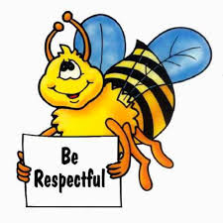
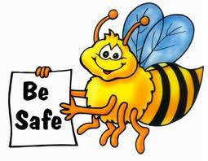
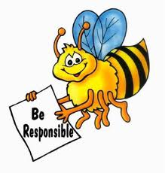
Kindergarten and 1st Grade Reflection
Name: ____________________________
Date: ____________________________

1. Write and draw a picture about my behavior.
__________________________________________________________________________________________________

---------------------------------------------------------------------------------------------------------------------------------------------------------------
__________________________________________________________________________________________________

__________________________________________________________________________________________________

---------------------------------------------------------------------------------------------------------------------------------------------------------------
__________________________________________________________________________________________________

2. Write and draw what I need to do instead.
__________________________________________________________________________________________________

---------------------------------------------------------------------------------------------------------------------------------------------------------------
__________________________________________________________________________________________________

__________________________________________________________________________________________________

---------------------------------------------------------------------------------------------------------------------------------------------------------------
__________________________________________________________________________________________________

3. Do I need to apologize to anyone? Did I apologize?
yes no yes no

to whom: ____________________________

Student Signature: _____________________________
Teacher Signature: ____________ Parent/Guardian Signature: ____________________

