Giffen Hallway Expectations

Be Safe | Be Respectful | Be Responsible
Keep hands, feet and objects to yourself  Walk carefully  Stay alert  Walk on the arrows  Stay to the right | Quiet wave  Appropriate voice  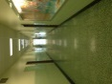  Be respectful of others work  Giffen Memorial Elementary School | Keep hallways clean  Stay with the line  Go straight to your destination  Report any incidents to an adult  Accept consequences graciously

