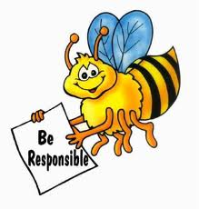
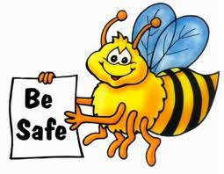
4th, 5th, and 6th Grade Reflection
Name: ____________________________

Date: ____________________________

1. What expectation did I not meet?
______________________________________________
______________________________________________
______________________________________________
______________________________________________

2. Why was my behavior a problem? (continue on back if needed)
______________________________________________
______________________________________________
______________________________________________
______________________________________________

3. What could I have done instead? (continue on back if needed)
______________________________________________
______________________________________________
______________________________________________
______________________________________________

4. Do I need to apologize to anyone? Did I apologize?
yes no yes no

to whom: ____________________

Student Signature: _____________________________
Teacher Signature: _____________________________
Parent/Guardian Signature: _____________________________

