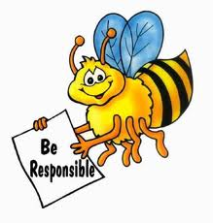
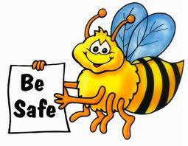
2nd and 3rd Grade Reflection
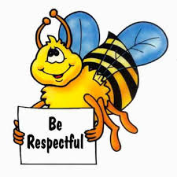
Name: ____________________________

Date: ____________________________

1. What expectation did I not meet?

________________________________
________________________________
________________________________
________________________________

2. Write and draw a picture about my behavior.
________________________________
________________________________
________________________________
________________________________

3. Write and draw what I need to do instead.

________________________________
________________________________
________________________________
________________________________

4. Do I need to apologize to anyone? Did I apologize?
yes no yes no

to whom: ____________________

Student Signature: _____________________________
Teacher Signature: _____________________________
Parent/Guardian Signature: _____________________________

